Thank you for purchasing the Alsoka Medical Microsuction Pump!

For more information on the pump, instructions for use or set up video please scan this QR code:


Please select the language of your preference on the website

Pump Set up and Care Tips and Tricks: -

- Please read and follow the manufacturers ‘Instructions for Use’ (IFU) before initial use.
- Start with a small amount of luke warm water (approx. 5-10mm) in the bottom of the cannister. This will help prevent wax sticking to the cannister, making cleaning easier.
- During microsuction procedures, have a small vessel of luke warm water beside you and regularly suck a small amount of water through the suction-tip to keep the tip clear.
- The cannister should NEVER be more than ½ full of liquid at any one time.
- Suction tips are single use only and should be used for one client only.
- The suction controller handle and silicon tubing can be used multiple times as they do not have direct patient contact. However, please inspect regularly for soiling and wear/tear and replace if necessary.
- At the end of a workday, suck a small amount of luke warm water followed by a mild detergent solution in water with the suction tip into the cannister.
- Disconnect the silicone tubing from the cannister and the suction controller handle and hang up in half to ensure all liquids can drain from both open ends.
- Inspect the tubing for soiling. If there is still solid material remaining, we recommend replacing.
- Remove the cannister from its bracket and empty and clean in line with the manufacturer’s IFU.
- Note that the short suction tubing and filter disk (between the cannister and the vacuum pump) shouldn’t require cleaning as no liquid is in contact with these. If they are accidentally exposed to liquid or become soiled, then replacement is recommended.

Our microsuctionpump has been tested and approved by ENT surgeons for earwax removal. Use the pump for that purpose in combination with the direct binocular vision of the Vorotek O Scope headworn microscope for client safety.

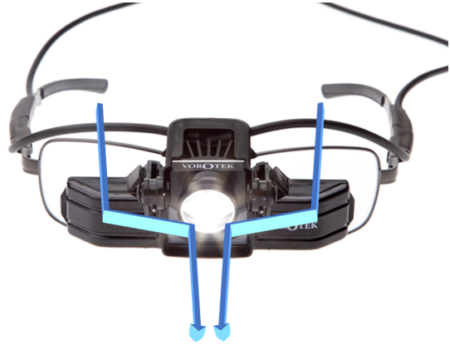
For more information on the Vorotek O Scope, or
to order more disposables such as suction tips, curettes etc, please scan this QR code:



